AP Studio Art Deadlines

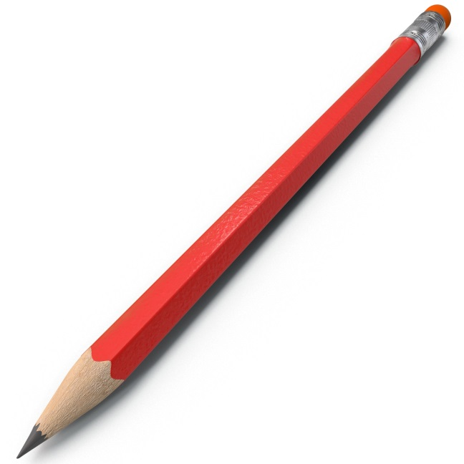**Concentration planning due 12/11**

**Scholastic due 12/13**

**December 21st First concentration piece due!**

**(Everyone must turn in an artwork for the first deadline**)

* January 4th Deadline #2
* January 11th Deadline #3
* January 18th Deadline #4
* February 1st Deadline #5
* February 8th Deadline #6
* February 15th Deadline #7
* February 22nd Deadline #8
* March 1st Deadline #9
* March 8th Deadline #10
* March 15th Deadline #11
* March 22nd Deadline #12
* March 29th Deadline #13
* April 5th Deadline #14
* April 12th Deadline #15

Everyone is allowed to skip any **three** deadlines!

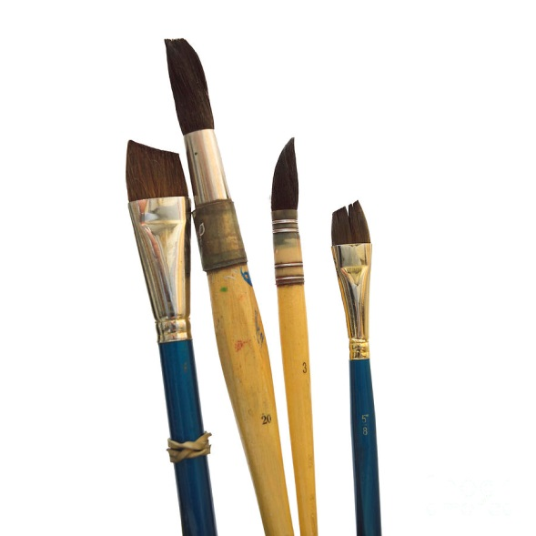For all Friday deadlines, you may submit a digital version of your artwork by **Sunday night** and it’s still on time! Good Luck! ☺

